**Task 1: Data Exploration and Cleaning**

**Load the dataset in SQL**

CREATE TABLE Customers (

customer_id INT PRIMARY KEY,

name VARCHAR(100),

age INT,

gender VARCHAR(10));

CREATE TABLE Products (

product_id INT PRIMARY KEY,

name VARCHAR(100),

category VARCHAR(50),

price DECIMAL(10, 2));

CREATE TABLE Sales (

transaction_id INT PRIMARY KEY,

customer_id INT,

product_id INT,

date DATE,

quantity INT,

amount DECIMAL(10, 2),

FOREIGN KEY (customer_id) REFERENCES Customers(customer_id),

FOREIGN KEY (product_id) REFERENCES Products(product_id));

CREATE TABLE Inventory (

product_id INT PRIMARY KEY,

stock_count INT,

FOREIGN KEY (product_id) REFERENCES Products(product_id));

* **Cleaning**

**To capitalise the initial letter of the names of customers.**

*select INITCAP (name) as new_full_name*

*from customers;*

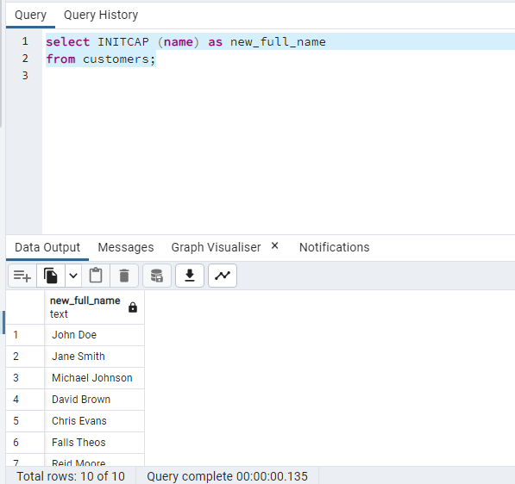

*Delete from customer*

*where age is null*

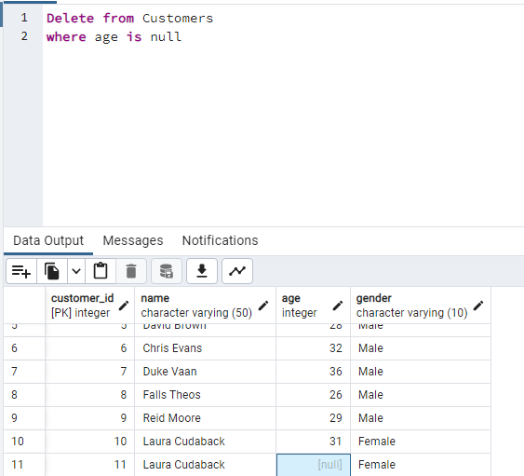

**Task 2: Data Analysis**

1. **Calculate the total revenue generated by the company for each product category.**

*select p.category, sum(s.amount) as total_revenue*

*from Products p*

*join sales s*

*on p.product_id = s.product_id*

*group by category*

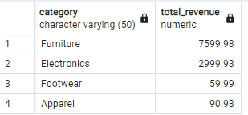

1. **Determine the top 5 customers who have made the highest total purchases, considering**

**the customer's age and gender.**

*select c.name, c.age, c.gender, s.amount*

*from Customers c*

*join sales s*

*on c.customer_id = s.customer_id*

*order by amount desc*

*limit 5*

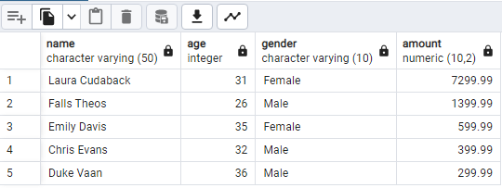

**3. Identify the most profitable product category by calculating the average revenue per unit**

**sold.**

*select category, AVG(amount/quantity) as Average_rev_per_unit*

*from products p*

*join sales s*

*on p.product_id = s.Product_id*

*group by category*

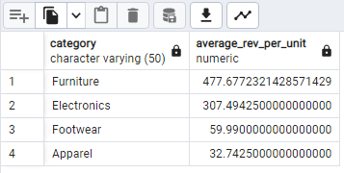

* *Furniture is the highest revenue category.*

**4. Analyse the inventory data and identify products that need restocking (stock count less**

**than a specified threshold).**

*select p.name, i.product_id, i.stock_count*

*from inventory i*

*join products p*

*on i.product_id = p.product_id*

*where stock_count < 55*

*order by stock_count asc*

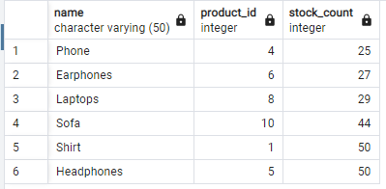

* *Threshold was below than 55 need restocking*

**Task 3: Advanced Analysis and Reporting**

**1. Write a SQL query to calculate the average age of customers for each product category**

*select p.category product_category, Avg(c.age) as Ave_Age_of_Customers*

*from customers c*

*join sales s*

*on c.customer_id = s.customer_id*

*join products p*

*on s.product_id = p.product_id*

*group by p.category*

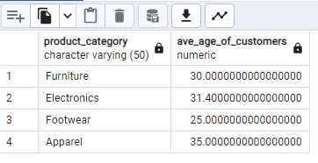

**2. Write a SQL query to retrieve the top 3 product categories that have the highest average**

**transaction amount.**

***select p.category, AVG(s.amount)***

***from products p***

***join sales s***

***on p.product_id = s.product_id***

***Group by p.category***

***limit 3***

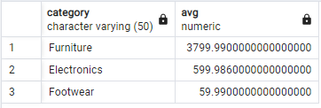

**Analysis Report**

I made an analysis of an ecommerce dataset, by studying the KPIs and using measures based on the dimensions of the data.

Calculated ***Total revenue*** generated by the company i.e. ***$10750.88*** with the ***Furniture*** as the highest profitable category. Along with this I made an analysis on the customers. The highest purchase was done by the ***Laura Cudaback*** i.e. ***$7299.99***

*Created the dynamic dashboard using PowerBI:*

